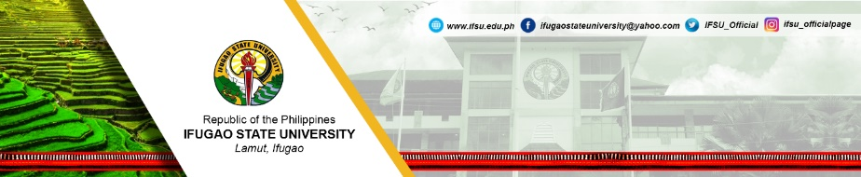
REQUEST FOR
WORK FROM HOME

Date: ________________________

_______________________________ _____________________ _____________________________
Name of Employee Position College/Department

Date of Requested WHF Schedule: ____________________________

WORK PLAN
Day/ Time | Target Work Deliverables/Activity | Expected Output/s

I commit to work on my targets and deliver my expected output/s. I understand that delivering less than what is indicated as my output shall affect the number of hours of service I render.  _______________________________  Name and Signature of Employee | _____ Approved: _____ Disapproved  ______________________________________________  Name and Signature of Immediate Supervisor/Department Head
 | Remarks:

(Form to be submitted at the DHRD Office after approval of Supervisor)

RECEIVED AT THE DHRD OFFICE:

_________________________________ _________________________
Name and Signature of Receiving Staff Date Received:
INDIVIDUAL ACCOMPLISHMENT REPORT

_______________________________ _____________________ _____________________________
Name of Employee Position College/Department

Date of Approved Work from Home: ____________________________

ACCOMPLISHMENT REPORT
Time  (8am -5pm) | Target | Output/s with Attachments | Remarks/Confirmation of Supervisor on Output/s
(Please use additional sheet if necessary)

__________________________________ ___________________
Signature of Employee Date Submitted

This is to certify that the above employee has delivered _______% of his/her work output as indicated in his/her work plan, proof attached.

___________________________________________________ _____________________
Name and Signature of Immediate Supervisor/Department Head Date

(Form to be submitted at the DHRD Office after signature of Supervisor)

RECEIVED AT THE DHRD OFFICE:

_________________________________ _________________________
Name and Signature of Receiving Staff Date Received:

