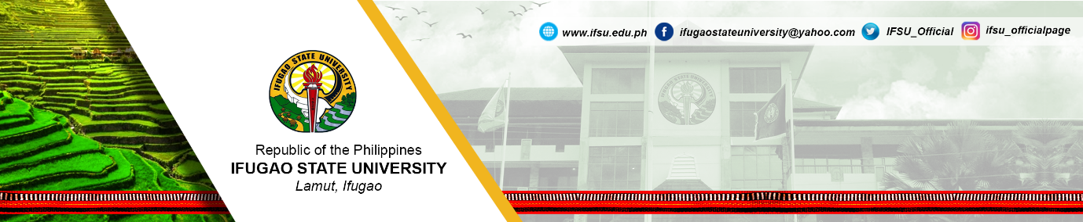
MONTHLY PERFORMANCE OUTPUT REPORT (MPOR)
For the Month of ______________ 2019

Form 1 - FACULTY WITH DESIGNATION

Employee:  ___________________________ | Office (Division/Region)  ____________________________________
PERFORMANCE OUTPUT
Deliverables by classification of functions | Actual Accomplishment  (Provide information on the indicator and accomplishment or the activity/ies performed to achieve the indicator. They must be arranged in accordance to the order of the PIs on the IPCR. To save space, indicators not planned to be achieved on the month may not be included.) | Week
 |  | 1 | 2 | 3 | 4
- Designation
- Functions as Faculty Member
- Higher Education Program/ Advanced Education Program
- Research Development
- Extension & Training
- Common Indicators
- Others (if any)
MAN-DAYS LOST THRU ABSENCE | Week 1  Week 2  Week 3  Week 4 | ___________  ___________  ___________  ___________
OBSERVATIONS/REMARKS
_______________________________  Employee’s Signature  Date: __________ | _______________________________  Supervisor’s Printed Name & Signature  Date: __________

